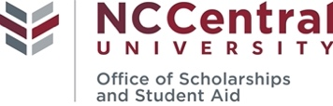
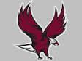
Parent PLUS Loan Instructions
www.studentaid.gov

After accepting the PLUS Loan through Banner SSB (MyEOL) or award letter, you must complete the steps below for the PLUS Loan application to process!!!

Step 1: Go to studentaid.gov Step 2: Log In using FSA ID & Password (Parent)
PARENT must sign in with FSA ID & password
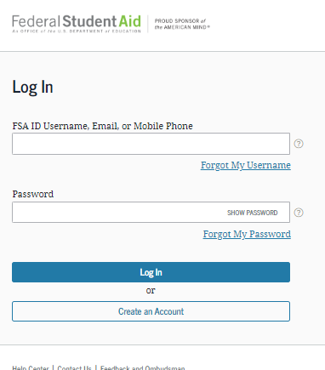
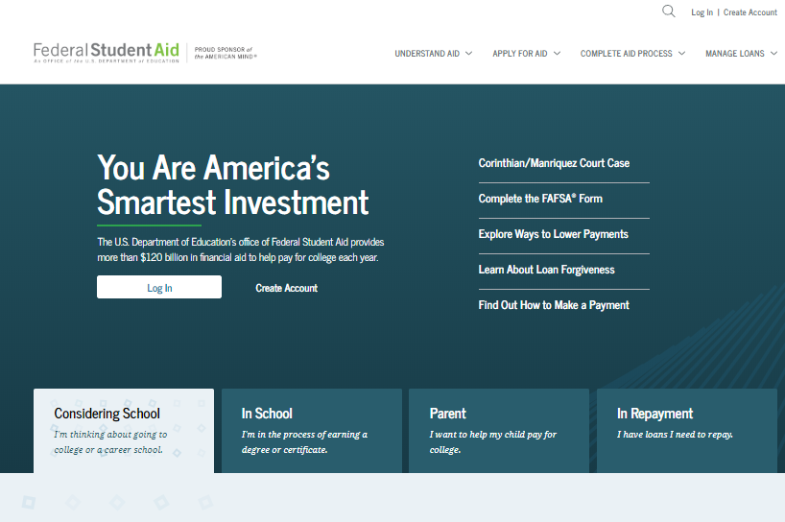

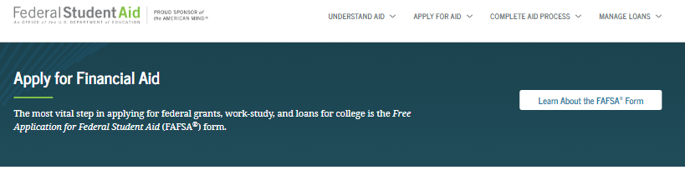
Step 3: Select “APPLY FOR AID”
Step 4: Scroll Down then Select “Apply for a Parent PLUS Loan”
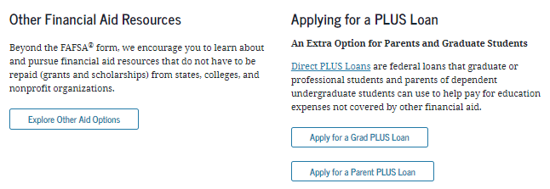

Once the PLUS application is submitted, an electronic confirmation will be transmitted to NCCU’s Scholarships and Student Aid Office. Please be aware that it may take 24 to 48 hours for NCCU to receive your submitted application.
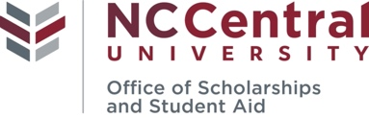
FEDERAL DIRECT PARENT PLUS LOAN APPLICATION INSTRUCTIONS

In order to obtain a Federal Direct Parent PLUS loan, the student must first complete the Free Application for Federal Student Aid (FAFSA) at https://fafsa.gov. Please review your 2020-20201 award letter for the offered amount of the Federal PLUS Loan.

Completing the Online Application:
Apply for a Federal Direct PLUS Loan at www.studentaid.gov. If you have problems with the online PLUS application process, you can contact Direct Loan Applicant Services at 1-800-557-7394 for assistance.

1. Sign in with your FSA ID and password

IMPORTANT: The borrowing parent must sign-in using their FSA ID and password

2. Click on “APPLY FOR AID” then “Apply for a PLUS Loan”
3. Under Select the loan type of Direct PLUS Loan application you would like to complete, choose the 2nd Start button
Step 1. School & Loan Information
- Select Award Year (2020-2021)
- Complete Student Information Section
- Complete School and Loan Information Section
Note: If you do not know the amount you want to borrow, save the application and contact NCCU’s Scholarships and Student Aid Office at 919-530-6180 to help determine an amount. NCCU cannot process a loan without a definitive request.
- Select Loan Period for Loan
08/2020-05/2021 = Full Academic Year loan (if student will be enrolled for both semesters, please choose this option)
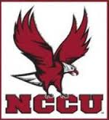
08/2020-12/2020 = Fall 2020 ONLY loan
01/2021-05/2021 = Spring 2021 ONLY loan
Step 2. Borrower Information
Complete all sections of Borrower Information.
Step 3. Review Request
Review all information under School and Loan Information and Borrower Information. Click Edit to update any information.
Step 4: Credit Check & Submit
Review and check consent for credit check and certification of information.

If the PLUS loan is credit approved, it will be added to the student’s financial aid award once NCCU receives the application.

If the PLUS loan is credit Denied, you may choose to proceed by selecting one of the following credit actions. The PLUS loan will then be processed based on the selected credit action.
- Contact Application Services at 800.557.7394 to speak with a representative from the U.S. Department of Education (Monday-Friday, 8 a.m. to 8 p.m. ET) or find an endorser for the loan and complete an official endorser addendum located on www.studentaid.gov This must be submitted with the ticket number assigned to you by the U.S. Department of Education Application Services Department.
- Provide documentation of extenuating circumstances to appeal the credit decision.
- Direct PLUS Loan borrowers who are denied and receive a credit override or seek an endorser will then be required to complete the new PLUS Credit Counseling online at www.studentaid.gov. This counseling is separate from the entrance counseling requirement for first time loan borrowers.
- Will not pursue a Direct PLUS Loan endorser/co-signer. If you choose not to pursue, your student may be eligible to receive additional unsubsidized loan funds of $4,000 (Freshman/Sophomores) or $5,000 (Juniors/Seniors).

Once the PLUS application is submitted, an electronic confirmation will be transmitted to NCCU’s Scholarships and Student Aid Office. Please be aware that it may take 24 to 48 hours for NCCU to receive your submitted application.

A Master Promissory Note must be completed for all parents borrowing a Federal Direct PLUS loan. The Parent PLUS MPN can be completed at www.studentaid.gov under “COMPLETE AND PROCESS” link. The Parent PLUS MPN must be completed if you meet one of the following conditions: a.) never signed a Direct PLUS Loan MPN, b.) signed an MPN more than one year ago but no loan disbursed or c.) signed an MPN more than 10 years ago or you obtained an endorser due to adverse credit history. Parent borrowers must complete and sign a separate MPN for each student for whom they are borrowing.

New Requirement for Loans: Department of Education Annual Student Loan Acknowledgement
Beginning the 2021-2022 academic year, the Department of Education has implemented a new requirement for all students (undergraduates, graduates, and professional) and parents to view, confirm, and acknowledge how much is currently owed in federal student loans. Direct Loans for students and parents will not disburse until the Annual Student Loan Acknowledgement has been completed.

