Instructions for Sign
- Remove any graphics that are not applicable
- Edit the PPE required to match your requirements
- If lab has biosafety hazards, fill in biosafety level 1 or 2 below picture
- Complete office and after-hours numbers for PI and lab manager
- If no lab manager, designate backup person and provide name and numbers
- Print sign in color and post on all lab entry doors

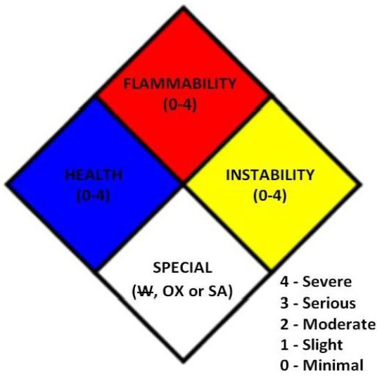
Instructions (cont)
- NFPA diamond
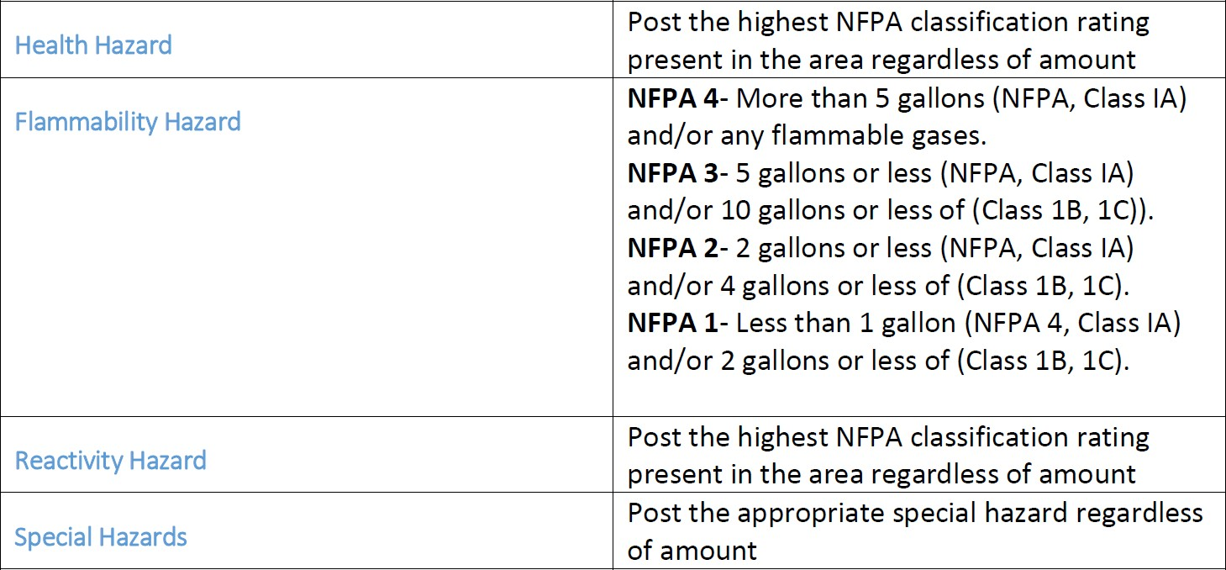
- To find the NFPA rating for a chemical, refer to the SDS, chemical label or contact EHS

0
3
0
Example

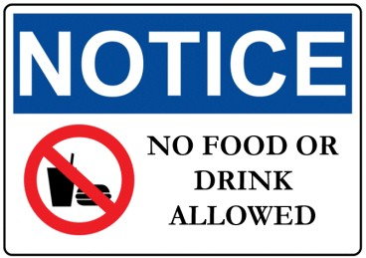
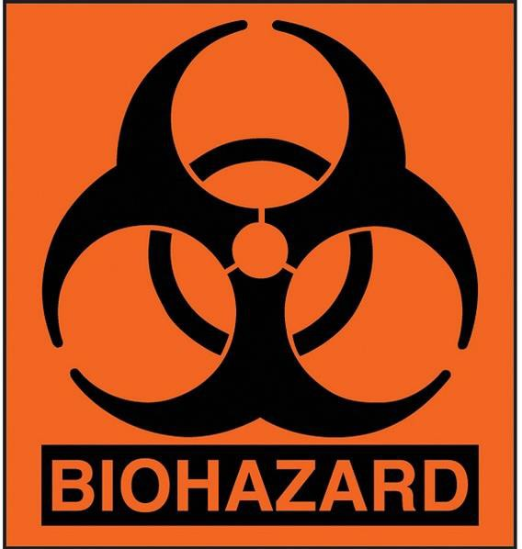
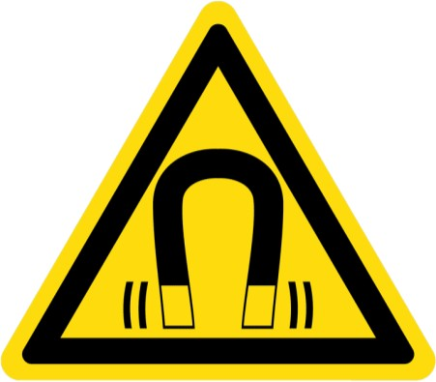
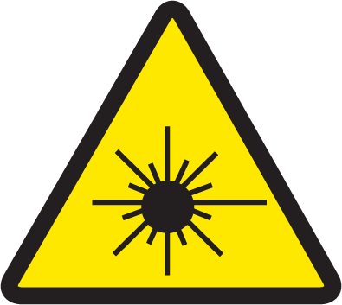
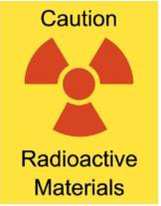
Caution
Admission to Authorized Personnel Only

- Lab Coat
- Eye Protection
- Gloves
Required Personal Protective Equipment

Title | Name | Office Phone | After-hours
Principal Investigator
Lab Manager
Environmental  Health & Safety |  | 919-530-7125 | 919-530-6106
University Police |  | 919-530-6106 or 911 | 24 hours

Biosafety Level 1 or 2

