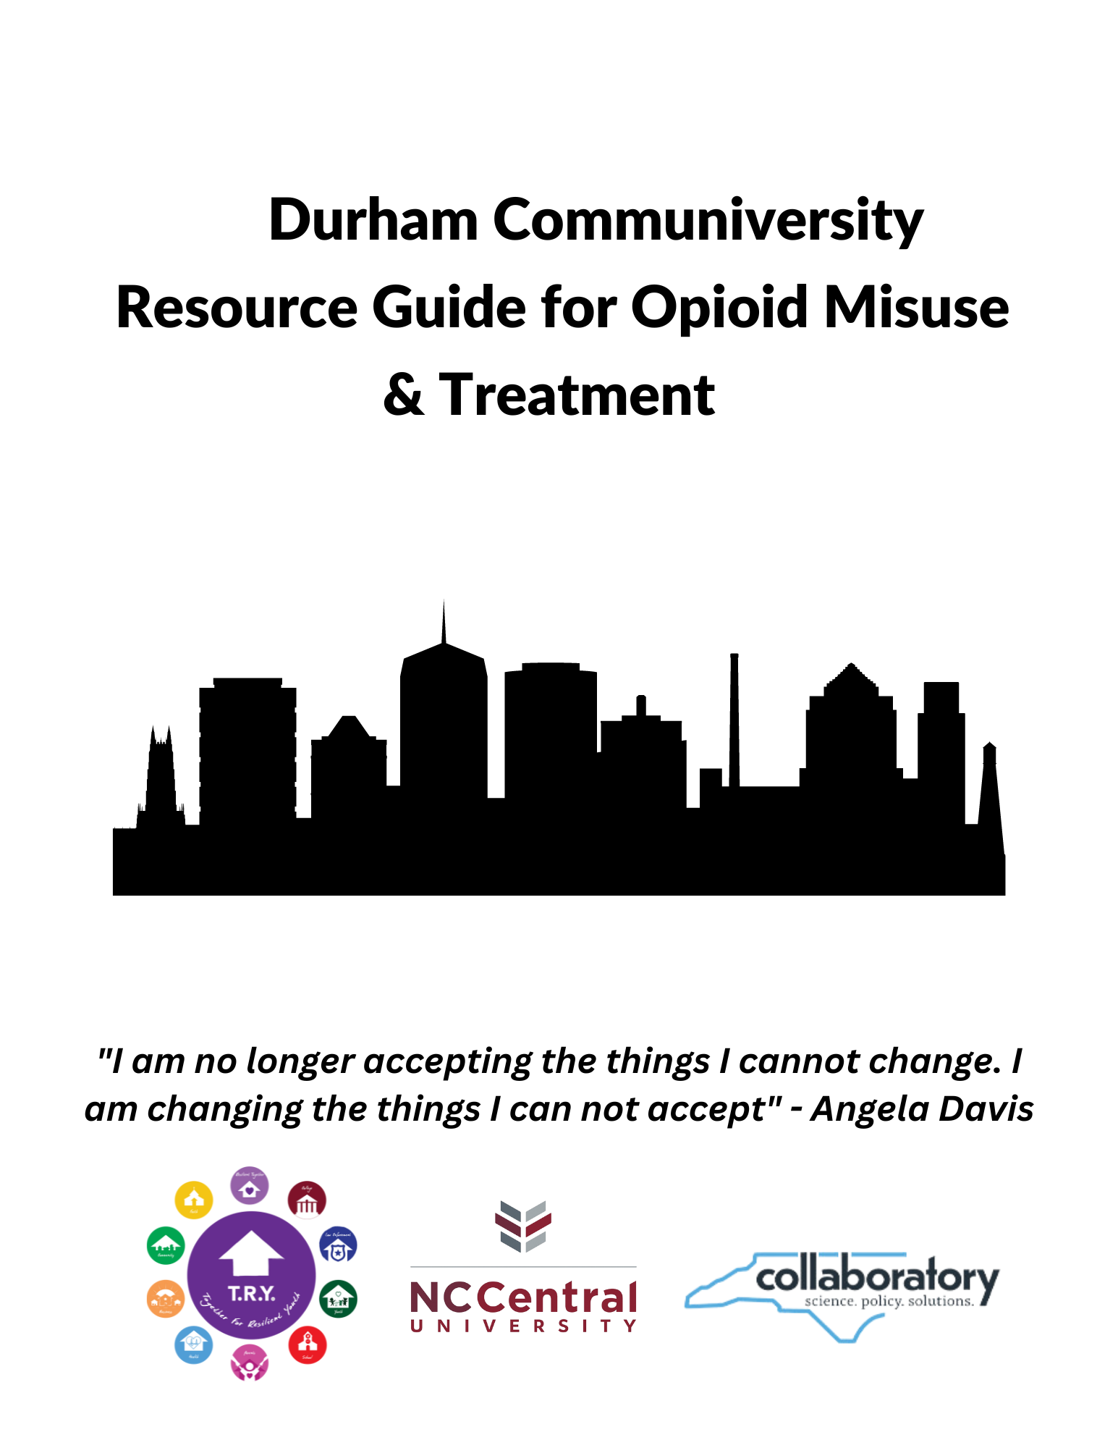

**Table of Contents**

1. Medication Assisted Treatment Locations
2. Medication Drop Box Locations
3. Where to Access Naloxone
4. Local Pharmacies
5. Therapy & Counseling Providers
6. Mental Health Services in Durham Public Schools
7. Resources for Pregnant and Parenting People
8. In-Patient Substance Abuse Recovery/ Housing
9. Formerly Incarcerated Transition
10. Peer Support Services
11. Veteran Support
12. Substance Use Prevention Resources
13. Recovery and Support Resources

|  |
| --- |
| **I. Medication Assisted Treatment Locations** |

|  |  |
| --- | --- |
| **B & D** | 249 NC Highway 54, Suite 320  Durham, NC 27713  919-907-3334  <http://bdintegratedhealth.com> |
| **BAART** | 800 North Magnum Street  Suite 400  Durham, NC 27701  919-683-1607  <https://baartprograms.com/baart-durham> |
| **Durham Recovery Response Center** | 309 Crutchfield Street  919-560-7305  Durham, NC 27701  <http://www.RIInternational.com> |
| **DURHAM TREATMENT CENTER** | 1913 Lamar Street  Durham, NC 27705  919-286-1509  Contact: Krystal Black  <https://www.newseason.com> |
| **Eleanor Health** | 3711 University Drive  Durham, NC 27707  919-765-8730  <https://www.eleanorhealth.com> |
| **Hope Centre for Advancement** | 701 Morreene Road  Durham, NC 27705  919-383-0426 |
| **Lincoln Community Health Center** | 1301 Fayetteville Street  Durham, NC 27701  919-956-4057  <http://lincolnchc.org> |
| **VA Medical Center of Durham** *(For veterans only)* | 508 Fulton Street  Durham, NC 27705  919-286-0411 Ext. 172383  <https://www.va.gov/durham-health-care> |

**II. Medication Drop Box Locations**

|  |  |
| --- | --- |
| **Carolina Behavioral Care Pharmacy** | 4102 Ben Franklin Boulevard  Durham, NC 27704 |
| **Durham County Department of Public Health** | 414 East Main Street  Durham, NC 27701  [919-560-7600](https://www.bing.com/ck/a?!&&p=dde371616ef1d24aJmltdHM9MTY3Mjk2MzIwMCZpZ3VpZD0wNTViNmZiNC0xZGY5LTZmMTctMzczMi03ZGNlMWNhYjZlOGQmaW5zaWQ9NTYyNA&ptn=3&hsh=3&fclid=055b6fb4-1df9-6f17-3732-7dce1cab6e8d&psq=durham+county+department+of+public+health&u=a1dGVsOjkxOTU2MDc2MDA&ntb=1)  <https://www.dcopublichealth.org/> |
| **Durham County Justice Center** | 510 South Dillard Street  Durham, NC 27701 |
| **Durham County Sheriff’s Office, North** | 11821 U.S. 501 North Rougemont  Durham, NC 27512 |
| **Durham Police Department, District 2** | 5285 North Roxboro Road  Durham, NC 27712 |
| **Durham Police Department, Headquarters** | 505 West Chapel Hill Street  Durham, NC 27701 |
| **NCCU (North Carolina Central University) Police Station Headquarters** | 2010 Fayetteville Street  Durham, NC 27707 |

**III. Where to Access Naloxone**

|  |  |
| --- | --- |
| **Durham County Department of Public Health Pharmacy** | 414 East Main Street  Durham, NC 27701  919-560-8223 |
| **Durham County EMS Community Paramedics** | 201 E. Main Street  Durham, NC 27701  919-560-8223  [Communityparamedic@dconc.gov](mailto:Communityparamedic@dconc.gov) |
| **NC Harm Reduction Coalition** | Durham Needle Exchange  4024 Barret Drive  Raleigh, NC 27609  919-370-0671  [Loftin@nchrc.org](mailto:Loftin@nchrc.org) |

**IV. Local Pharmacies**

|  |  |
| --- | --- |
| **Carolina Behavioral Care Pharmacy** | 4102 Ben Franklin Boulevard  Durham, NC 27704  919-688-8978 |
| **Duke Campus Center Pharmacy** | For Duke University students, staff, and faculty  305 Towerview Drive  Durham, NC 27708  919-385-3784 |
| **Gurley’s Pharmacy Inc.** | 114 West Main Street  Durham, NC 27701  919-688-8978 |
| **Josef’s Pharmacy** | 3421 North Roxboro Street  Durham, NC 27704  919-680-1540 |
| **Main Street Pharmacy** | 213 West Main Street  919-688-1368 |
| **Triangle Pharmacy** | 1700 East Highway 54  Durham, NC 27713  919-544-1711 |
| **Upchurch Drugs** | 5108 Roxboro Road  Durham, NC 27704  919-477-7325 |

**V. Therapy & Counseling Providers**

|  |  |
| --- | --- |
| **CAARE-The Healing Center** | 214 Broadway Street  Durham, NC 27701  919-683-5300  [www.caare-inc.org](http://www.caare-inc.org) |
| **Carolina Community Support Services** | 411 Andrews Road  Suite 130  Durham, NC 27705  919-682-5777  <http://www.carolinacss.com/> |
| **Durham Recovery Response Center** | 309 Crutchfield Street  Durham, NC 27704  919-560-7305  <http://www.RIInternational.com> |
| **El Futuro-Durham** | 2020 Chapel Hill Road  Suite 23  Durham, NC 27707  919-688-7101  <https://elfuturo-nc.org/> |
| **Freedom House Recovery Center** | 400-D Crutchfield Street  Durham, NC 27701  919-251-8806  <https://freedomhouserecovery.org> |
| **VA Mental Health** *(For veterans only)* | 508 Fulton Street  Durham, NC 27705  919-286-0411 Ext 177483  <https://www.va.gov/durham-health-care> |

**VI. Mental Health Services in Durham Public Schools**

|  |
| --- |
| **Comprehensive clinical assessments, individual, family and group therapy for students are available within these schools:**  **C.C Spaulding Elementary, Club Boulevard Elementary, Fayetteville Street Elementary, Hope Valley Elementary, Parkwood Elementary, Parkwood Elementary, Lowes Grove Middle School, Rogers-Herr Middle School, Shepard Middle School, Durham School of the Arts, Riverside High School** |

**VII. Resources for Pregnant and Parenting People**

|  |  |
| --- | --- |
| **Alcohol and Drug Council of North Carolina**  Provides education and support resources to pregnant women and parents. | 800-688-4232  <https://www.alcoholdrughelp.org/> |
| **Community Choices- CASCADE at Durham**  Provides accessible services for those struggling with substance misuse disorder. | 3325 Chapel Hill Boulevard  Durham, NC 27707  919-490-6900  <http://www.comalt.org> |
| **Exchange Family Center**  Provides family support, counseling and training for both parents and children. | 3400 Croasdaile Drive  Suite 206  Durham, NC 27705  919-403-8249  <https://www.exchangefamilycenter.org> |

**VIII. In Patient Substance Abuse Recovery / Housing**

|  |  |
| --- | --- |
| **Comfort Transitional Living**  Transitional and sober housing for both men and women. | Men and Women’s House: 1809 Vale Street  Men’s House: 1813 Vale Street  Durham, NC 27705  Larry McGill 919-519-2900  Eric Prince 919-884-7135 |
| **Durham Rescue Mission**  Provides shelter and recovery resources for substance misuse disorder. | 1201 East Main Street (Men)  507 East Knox Street (Women and Children)  Durham, NC 27701  919-688-9641  <http://www.durhamrescuemission.org> |
| **Families Moving Forward (Genesis Home)**  Provides emergency shelter and supportive services to 21 families in the facility at a time. | 300 N. Queen Street  Durham, NC 27701  919-683-5878  [www.fmfnc.org](http://www.fmfnc.org)  To apply, call Entry Point Durham: (984) 287-8313 |
| **Freedom House**  Traditional (short-term) housing, treatment, and recovery services for people with substance use disorder. | Men’s House: 529 Holloway Street  919-425-5472  Women’s House: 407 Salem Street  Durham, NC 27701  919-957-7386  <https://freedomhouserecovery.org/> |
| **Housing for New Hope Shelter and Housing Programs**  Provides housing, rapid rehousing and advocacy for individuals. | 8 West Colony Place  Suite 250  Durham, NC 27705  919-489-6282  Shanika Etheridge - Property Manager 919-717-9603  [www.housingfornewhope.org](http://www.housingfornewhope.org) |
| **Just a Clean House**  Long-term recovery for men in recovery from substance use disorder. | 919-381-9494  <https://www.justacleanhouse.com> |
| **Magnolia’s Recovery and Transitional House**  Christian-based recovery housing for women 18+ | 1110 Red Oak Avenue  Durham, NC 27704  Tanisha Adams: 919-308-1332  Chrystal Williams: 919-452-5356  Email: [magnoliasrecoveryhouse@gmail.com](mailto:magnoliasrecoveryhouse@gmail.com) |
| **Oxford House**  Self-run, self-supported housing. | For general information on Oxford House:  (336) 250-9370  <https://oxfordhousenc.org>  For the address and phone number of each Oxford House in Durham: <https://www.oxfordvacancies.com/> |
| **Project FAM at the LGBTQ Center of Durham**  Provides housing navigation, financial assistance, and LGBTQ+ resources. Does NOT offer emergency housing. | 114 Hunt Street  Durham, NC 27701  919-827-1436  [www.lgbtqcenterofdurham.org/program/project-fam](http://www.lgbtqcenterofdurham.org/program/project-fam) |
| **Recovery Connections**  Provides treatment to individuals with addictions and other substance misuse disorder. | 2913 Wadsworth Avenue  Durham, NC 27707  Pastor Bernie Bass (919) 638-4755 |
| **The Maple Court Veterans Housing Program**  Provides housing services and resources to veterans. | 207 Commons Boulevard  Durham, NC 27704  919-477-0571 / 919-477-0592  [www.voachesapeake.org/maplecourt](http://www.voachesapeake.org/maplecourt) |
| **TROSA**  Provides a FREE 24-month in-patient program. Food, housing, and behavioral/mental health services are provided at no cost. | 1820 James Street  Durham, NC 27707  919-419-1059 (Admissions)  <https://trosainc.org/> |
| **Urban Ministries of Durham (UMD)**  Provides food, shelter, and case management to both men and women. | 410 Liberty Street  Durham, NC 27701  919 682-0538  [www.umdurham.org](http://www.umdurham.org) |

**IX. Formerly Incarcerated Transition**

|  |  |
| --- | --- |
| **Crossroad Transitional Housing**  Crossroad Transitional Housing is a 4-bed house for formerly incarcerated men. | 1109 Raynor Street  Durham, NC 27703  Lawrance Harris (984) 215-1685  The case manager or parole officer should email: [harrislawrance@gmail.com](mailto:harrislawrance@gmail.com) or text (984) 215-1685 with the person’s name and prison number. Lawrance Harris will respond in 2-3 days and set up a phone interview with the person. |
| **FIT Program**  A Community Health Worker (CHW) works directly with the formerly incarcerated individual after release to achieve successful reentry and specifically to facilitate connections with primary medical care, and if needed behavioral health and substance use treatment. | 414 E Main Street  Durham, NC 27701  Referral to the FIT Program Contact:  Dorel Clayton 919-672-8929 Email: [dclayton@dconc.gov](mailto:dclayton@dconc.gov) |
| **Jubilee Home**  Provides housing for young men who are transitioning from incarceration to independence. (Ages 17+) | 404 E. Umstead Street  Durham, NC 27707  919-381-4431  [www.jubilee-home.org](http://www.jubilee-home.org)  Fill out a referral form at [www.jubilee-home.org/](http://www.jubilee-home.org/) contact and email it to [info@jubilee-home.org](mailto:info@jubilee-home.org) or call (919) 381-4431 for assistance. |
| **Reservoir of Hope**  Provides housing for men who have recently been released from incarceration or hospitalization. | P.O. Box 52261  919-428-3132  Email: [resofhope@gmail.com](mailto:resofhope@gmail.com) to set up an interview. |
| **Restorative Transitions**  Works with men and women who are either coming directly out of incarceration or who are currently living in the community and are justice-involved. | PO Box 52271  Call to apply or visit website for program overview  919-726-7055  [www.restorativetransitions.org](http://www.restorativetransitions.org) |

**X. Peer Support Services**

|  |  |
| --- | --- |
| **Community Linkages to Care (CLC)**  919-695-3246  <https://www.dcopublichealth.org/> | Peer Support Specialists are people who have lived experience with substance use or mental illness. They are trained to help others connect to services. CLC Peer Support Specialists provide the following services, free of charge:   * Take-home naloxone kits to reverse an overdose. * Connections to treatment and care, whenever you are ready. * Links to harm reduction, housing, food, and job resources * Car rides or bus passes to access services * Help in developing coping skills and avoiding triggers. * Help with developing a network of support from family, friends, and others. * Assistance in preparing for recovery meetings. |
| **Southlight Healthcare** | 919-787-6131  1201 N. Roxboro Street 27701  www.southlight.org |
| **B & D Integrated Health Services** | 919-907-3334  249 East NC Highway 54 STE 320 27713  <https://www.bdintegratedhealth.com/> |

**XI. Veteran’s Support**

|  |  |
| --- | --- |
| **Veteran’s Crisis Line**  1(800) 273-8255  <https://www.veteranscrisisline.net/> | Veterans or family members can call this line to receive confidential support. |

**XII. Substance Use Prevention Resources**

|  |  |
| --- | --- |
| **Center for Child and Family Health** | 1121 West Chapel Hill Street  Suite 100  Durham, 27701  919-419-3474  <https://www.ccfhnc.org/> |
| **Together for Resilient Youth (TRY)** | 919-491-7811  <https://www.together4resilientyouth.org> |

**XIII. Recovery & Support Resources**

|  |  |
| --- | --- |
| **Durham Wellness City** | 2609 N. Duke Street  Suite 304  Durham, NC 27704  919-687-4041  <http://www.RIInternational.com> |
| **Narcotics Anonymous Meeting Search** | <https://www.na.org/meetingsearch/> |
| **Other 12-Step Fellowship Meetings** | <https://meetings.intherooms.com/> |
| **Recovery Community of Durham** | 1209 North Elizabeth Street  Durham, NC 27701  919-641-9988  <https://recoverycommunityofdurham.org/> |
| **Al-Anon**  For family and friends of those with substance misuse disorder. Find a meeting in person or online. | <https://al-anon.org/al-anon-meetings/find-an-al-anon-meeting/> |
| **She Recovers Foundation**  Virtual recovery meetings for women in or seeking recovery. | <https://sherecovers.org/> |